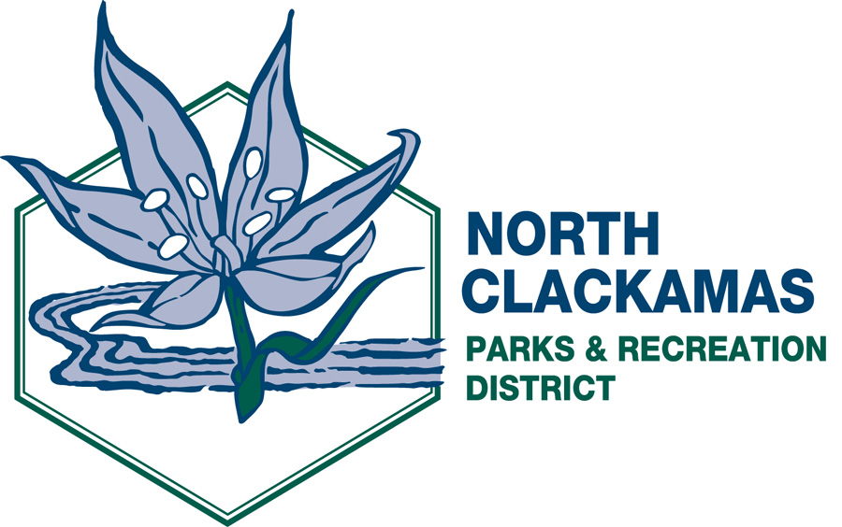

NORTH CLACKAMAS PARKS AND RECREATION DISTRICT
District Advisory Board
Wednesday, November 9, 2011 – 5:30 p.m.
Oak Lodge Sanitary District
14611 SE River Road, Milwaukie 97267

- Call to Order

- Citizen Participation **

- Approval of Minutes from October 13, 2011

- Presentations
- Marketing Update and Work Plan – Debbie Ibarra 30 min
- Master Plan Update – Katie Dunham 10 min
- Milwaukie Center Annual Report – Joan Young 20 min
- 1st Quarter Financial and Audit Report – Laura Zentner 15 min
- DAB Survey Discussion 20 min

- Division Reports – Michelle Healy, Dave Miletich and Laura Zentner

- Director’s Comments

- Board Members’ Comments

- Adjournment

** Public comment will be limited to three (3) minutes per individual.

The agenda and related documents are posted on the NCPRD website at www.ncprd.com.

