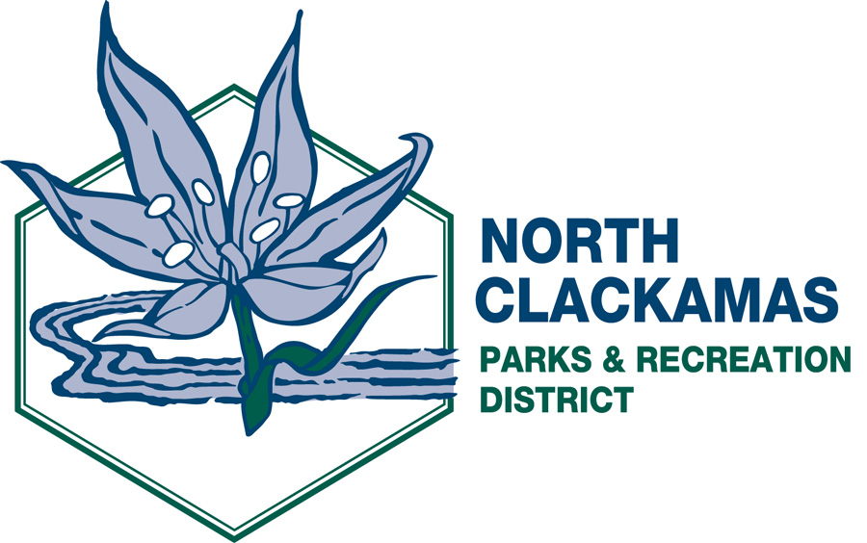

NORTH CLACKAMAS PARKS AND RECREATION DISTRICT
District Advisory Board
Thursday, October 13, 2011 – 5:30 p.m.
Milwaukie Center

- Call to Order

- Citizen Participation **

- Approval of Minutes from September 8, 2011

- Presentations

- C/CAB Reappointments – Joan Young, ACTION 5-10 min

- Advisory Board Roles – Gary Schmidt, PGA DISCUSSION 15 min

- Friends of North Clackamas Parks – Susan Shawn, DISCUSSION 15 min

- Fire Management Plan Update – Tonia Burns, DISCUSSION 15 min

- Aquatic Park/Recreation After-Summer Update – Kandi Ho, DISCUSSION 15-20 min

- Division Reports – Michelle Healy, Dave Miletich and Laura Zentner

- Director’s Comments

- Board Members’ Comments

- Adjournment

** Public comment will be limited to three (3) minutes per individual.

The agenda and related documents are posted on the NCPRD Web site at www.ncprd.com.

