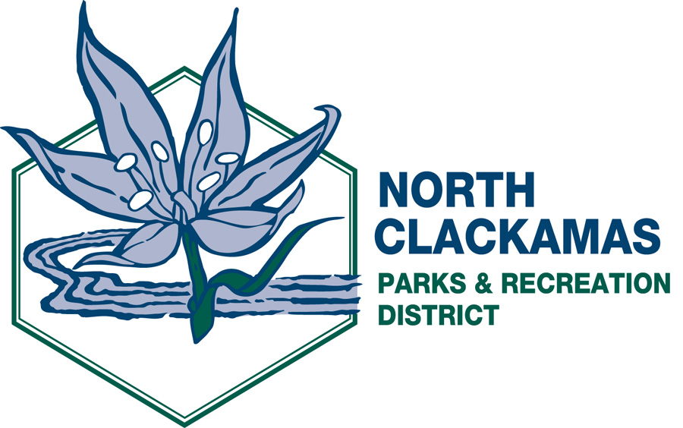

NORTH CLACKAMAS PARKS AND RECREATION DISTRICT
District Advisory Board
Thursday, September 8, 2011 – 5:30 p.m.
Happy Valley City Hall
16000 SE Misty Drive, Happy Valley 97086

- Call to Order

- Citizen Participation **

- Approval of Minutes from August 11, 2011

- Presentations

  - Park Avenue Station Planning (DISCUSSION) – Shari Gilevich, Clackamas County Planning

  - Mt. Scott/Scouter Mountain Update (DISCUSSION) – Katie Dunham

- Division Reports – Michelle Healy and Dave Miletich

- Director’s Comments

- Board Members’ Comments

- Adjournment

** Public comment will be limited to three (3) minutes per individual.

The agenda and related documents are posted on the NCPRD Web site at www.ncprd.com.

